VMC TE -­‐ Series

TE-1055 Operation Manual Electric wiring diagram

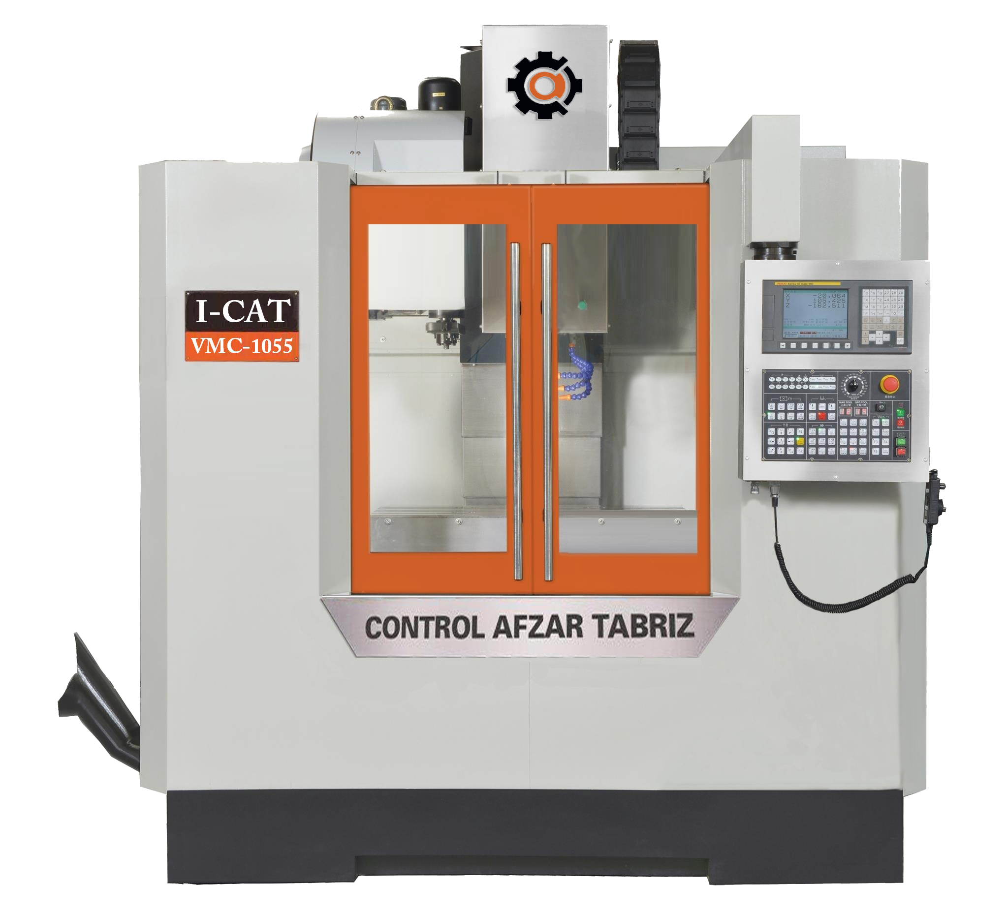

Warranty Certificate
Covering Takam Technology Machine Ltd., Co. CNC Equipment Effective January 1, 2011

LIMITED WARRANTY COVERAGE
All new Takam Series Machining Centers are warranted exclusively by the Takam Machine ("Manufacturer") limited warranty as follows:
Each Takam CNC machine ("Machine") and its components ("Components") (except those listed below under limits and exclusions) is warranted against defects in material and workmanship for a period of one (1) year from the date of purchase, which is the date that a machine is installed at the end user. The foregoing is a limited warranty and it is the only warranty by manufacturer. Manufacturer disclaims all other warranties, express or implied, including but not limited to all warranties of merchantability and fitness for a particular purpose.

REPAIR OR REPLACEMENT ONLY: MANUFACTURER'S LIABILITY UNDER THIS AGREEMENT SHALL BE LIMITED TO REPAIRING OR REPLACING, AT THE DISCRETION OF MANUFACTURER, PARTS, OR COMPONENTS.

An additional one-year warranty extension may be purchased from your authorized Takam distributor.
LIMITS and EXCLUSIONS of WARRANTY
Except as provided above, buyer agrees that all warranties express or implied, as to any matter whatsoever, including but not limited to warranties of merchantability and fitness for a particular purpose are excluded. Components subject to wear during normal use and over time such as paint, window finish and condition, light bulbs, seals, chip removal system, etc., are excluded from this warranty.
Factory-specified maintenance procedures must be adhered to and recorded in order to maintain this
warranty.
This warranty is void if the machine is subjected to mishandling, misuse, neglect, accident, improper installation, improper maintenance, or improper operation or application, or if the machine was improperly repaired or serviced by the customer or by an unauthorized service technician. Warranty service or repair service is available from the authorized Takam distributor.

Without limiting the generality of any of the exclusions or limitations described in other paragraphs. manufacturer's warranty does not include any warranty that the machine or components will meet buyer's production specifications or other requirements or that operation of the machine and components will be uninterrupted or error-free. Manufacturer assumes no responsibility with respect to the use of the Machine and Components by Buyer. and manufacturer shall not incur any liability or Seller to Buyer far any failure in design, production, operation, performance or otherwise of the Machine or Components other than repair or replacement of same asset forth in the Limited Warranty above. Manufacturer is not responsible for any damage to parts, machines, business premises or other property of Buyer.or for any other incidental or consequential damages that may be caused by a malfunction of the Machine or Components.

LIMITATION OF LIABILITYAND DAMAGES: MANUFACTURER IS NOT LIABLE TO BUYER, SELLER OR ANY CUSTOMER OF BUYER FOR LOSS OF PROFITS, LOST DATA, LOST PRODUCTS, LOSS OF REVENUE, LOSS OF USE, COST OF DOWN TIME, BUSINESS GOOD WILL, ORANY OTHER INCIDENTAL OR CONSEQUENTIAL DAMAGE, WHETHER INAN ACTION IN CONTRACT OR TORT, ARISING OUT OF OR RELATED TO THE MACHINE OR COMPONENTS, OTHER PRODUCTS OR SERVICES PROVIDED BY MANUFACTURER OR SELLER, ORTHE FAILURE OF PARTS OR PRODUCTS MADE BY USING THE MACHINE OR COMPONENTS, EVEN IF MANUFACTURER OR SELLER HAS BEEN ADVISED OF THE POSSIBILITY OF SUCH DAMAGES. MANUFACTURER'S LIABILITY FOR DAMAGES FORANY CAUSE WHATSOEVER SHALL BE LIMITED TO REPAIR OR REPLACEMENT, AT THE DISCRETION OF MANUFACTURER, OF THE DEFECTIVE PARTS, COMPONENTS OR MACHINE.
Buyer has accepted this restriction on its right to recover incidental or consequential damages as part of its bargain with Seller. Buyer realizes and acknowledges that the price of the equipment would be higher if Seller or Manufacturer were required to be responsible for incidental or consequential damages, or punitive damages.

This Warranty Certificate supersedes any and all other agreements. either orator in this writing. between the parties hereto with respect to the warranties, limitations of liability and/or damages regarding the Machine or Components. and contains all of the covenants and agreements between the parties with respect to such warranties. liability limitations and/or damages. Each party to this Warranty Certificate acknowledges that no representations, inducements, promises. or agreements orally or otherwise have been made by any party or anyone acting on behalf of any party which are not embodied herein regarding such warranties, liability limitations and/or damages, and that no other agreement. Statement or promise not contained in this Warranty Certificate shall be not valid or binding regarding such warranties, liability limitations and damages.

TRANSFERABILITY
This warranty is transferrable from the original end-user to another party if the machine is sold via private sale before the end of the warranty period.

- Safety Precautions

TABLE OF CONTENT
Page

1-1. Read Before Operating 2
1-2. Ground Connection 3
1-3. Important for Machine Accuracy 3
1-4. Warnings and Cautions 4-5
1-5. Warnings and Decal Symbols Reference 5-9
1-6. Unattended Operation 10
1-7. Improper Coolants 10
- Specifications
2-1. Outline of Main Units and Operation Position 11
2-1-1. Name of Machine parts 11
2-1-2. Operation Position 12
2-2. Outside Dimension 12
2-3. Machine Specifications 13
2-4. Noise Level 13
2-5. Tools Information 13
2-6. Lubrication Usage Types: 14
2-7. Accessories 14
- Handling and Transportation
3-1. Important Items before Unpacking
3-1-1. Marks on Wooden Box 15
3-1-2. Tools for Unpacking 15
3-2. Transportation before Unpacking 15-16
3-3. Transportation after Unpacking 16
3-4. Forklift and Crane Load Requirement 16
- Foundation and Installation
4-1. Requirement of Environment 17
4-2. Foundation and requirement 17
4-3. Requirement of Power Source
4-3-1. Main power supply 18
4-3-2. Air source limit 18

- Machine Level Adjusting
5-1. Machine Level Adjusting 19-20

- Maintenance
6-1. General Safety Rules 21
6-2. Daily Maintenance 21
6-3. Weekly Maintenance 21
6-4. Monthly Maintenance 21-22
6-5. Three-month Maintenance 22
6-6. Six-month Maintenance 22
6-7. Yearly Maintenance 22
6-8. Regular Maintenance Explanation
6-8-1. Maintenance of unclamp system 23
6-9. Pneumatic Circuit Unit
6-9-1. Following Motions are Controlled by Pneumatic System 24
6-9-2. FRL (Filter/Regulator/Lubrication) Unit 24-25
6-10. Maintenance of Lubrication System
6-10-1. Model:4 liter lubrication system (PLC Controlled System). 25
6-10-2. Operation Manual for Auto Lubrication Unit 25-26
6-10-3. Auto Lubrication Unit Trouble shooting 26-27
6-11. Cleaning and Remounting of Cutting Fluid Tank 27
- Alarm Description and Solution
7-1. What to do first. 28-30
7-2. Malfunction Analysis and Trouble-Shooting 31
(environmental factor)
- Additional Content
Section 1: Operating Explanation & Function List
Section 2: M and G Code.
Section 3: Machine Foundation Drawing.
Section 4: Machine BOM List. Section 5: Keeprelay Parameter Section 6: Alarm
Section 7: Laser & Accuracy report

SAFETY PROCEDURE

Don’t Get Caught Up In Your Work
All milling machines contain hazards from rotating parts, belts and pulleys, high voltage electricity, noise, and compressed air. When using CNC machines and their components, basic safety precautions must always be followed to reduce the risk of personal injury and mechanical damage.

IMPORTANT

THIS MACHINE TO BE OPERATED ONLY BY TRAINED PERSONNEL IN ACCORDANCE WITH THE OPERATORS MANUAL AND INSTRUCTIONS FOR SAFE OPERATION OF MACHINE.

  - READ BEFORE OPERATING THIS MACHINE:

    - Only authorized personnel should work on this machine. Untrained personnel present a hazard to themselves and the machine, and improper operation will void the warranty.

    - Check for damaged parts and tools before operating the machine. Any part or tool that is damaged should be properly repaired or replaced by authorized personnel. Do not operate the machine if any component does not appear to be functioning correctly. Contact your shop supervisor.

    - Use appropriate eye and ear protection while operating the machine. ANSI-approved impact safety goggles and OSHA-approved ear protection are recommended to reduce the risks of sight damage and hearing loss.

    - Do not operate the machine unless the doors are closed and the door interlocks are functioning properly. Rotating cutting tools can cause severe injury. When a program is running, the mill table and spindle head can move rapidly at any time in any direction.

    - The Emergency Stop button (also known as an Emergency Power Off button) is the large, circular red switch located on the Control Panel. Pressing the Emergency Stop button will instantly stop all motion of the machine, the servo motors, the tool changer, and the coolant pump. Use the Emergency Stop button only in emergencies to avoid crashing the machine.

    - The electrical panel should be closed and the three latches on the control cabinet should be secured at all times except during installation and service. At those times, only qualified electricians should have access to the panel. When the main circuit breaker is on, there is high voltage throughout the electrical panel (including the circuit boards and logic circuits) and some components operate at high temperatures. Therefore, extreme caution is required. Once the machine is installed, the control cabinet must be locked and the key available only to qualified service personnel.

    - DO NOT modify or alter this equipment in anyway. If modifications are necessary, all such requests must be handled by Takam Machines Ltd, Co. Any modification or alteration of any Takam Milling or Turning Center could lead to personal injury and/or mechanical damage and will void your warranty.

    - It is the shop owner's responsibility to make sure that everyone who is involved in installing and operating the machine is thoroughly acquainted with the installation, operation, and safety instructions provided with the machine BEFORE they perform any actual work. The ultimate responsibility for safety rests with the shop owner and the individuals who work with the machine.

  - Ground Connection

    - Both machine equipment and factory system are in common earth connection. (separateness is permitted)

    - The grounding wire must be an insulated wire of at least 5.5mm/

    - To use copper bar as a grounding terminal, its dia. must be at least 19mm and the length must be longer than 2 M.

    - According to electrician regulations of 3 phases with 4 wires, the resistance of ground connection system must be less than 25Q for high voltage equipment of non-ground connection system.

    - Earth bar must be rooted vertically at least 1M below the ground. In case of rock as an obstacle, it may be embedded horizontally at least 1.5M below ground.

    - The ground must be installed well to prevent personnel and machine from electric shock when the circuit is short.

  - Important for Machine Accuracy
Warm up the machine before using can help stabilize the accuracy of the machine. Please allow machine to warm up for about 10 to 20 minutes at 1000 rpm for spindle and half the maximum speed for three axes. Remember this is very important for the accuracy of machine.

  - OBSERVE ALL OF THE WARNINGS AND CAUTIONS BELOW:
    - This machine is automatically controlled and may start at anytime.

    - This machine can cause severe bodily injury.

    - Do not operate with the doors open.

    - Avoid entering the machine enclosure.

    - Do not operate without proper training.

    - Always wear safety goggles.

    - Never place your hand on the tool in the spindle and press any bottom to cause a tool change cycle. The tool changer will move in and crush your hand.

    - To avoid tool changer damage, ensure that tools are properly aligned with the spindle drive lugs when loading tools.

    - The electrical power must meet the specifications in this manual. Attempting to run the machine from any other source can cause severe damage and will void the warranty.

    - DO NOT press POWER UP/RESTART on the control panel until after the installation is complete.

    - DO NOT attempt to operate the machine before all of the installation instructions have been completed.

    - NEVER service the machine with the power connected.

    - Improperly clamped parts machined at high speeds/feeds may be ejected and puncture the safety door. Machining oversized or marginally clamped parts is not safe.

    - Windows must be replaced if damaged or severely scratched -Replace damaged windows immediately.

Do not process toxic or flammable material. Deadly fumes can be present. Consult material manufacturer for safe handling of material by-products before processing.

USES AND GUIDELINES FOR PROPER MACHINE OPERATION
All milling machines contain hazards from rotating cutting tools, belts and pulleys, high voltage electricity, noise, and compressed air. When using milling machines and their components, basic safety precautions should always be followed to reduce the risk of personal injury and mechanical damage. READ ALL APPROPRIATE WARNINGS, CAUTIONS, AND INSTRUCTIONS BEFORE OPERATING THIS MACHINE.

MODIFICATIONS TO THE MACHINE
DO NOT modify or alter this equipment in any way. If modifications are necessary, all such requests must be handled by Takam Machine Ltd, Co. Any modification or alteration of any Takam machining center could lead to personal injury and/or mechanical damage and will void your warranty.

WARNING!
NEVER DISABLE ANY SAFETY SWITCHES.
ALWAYS KEEP THE ELECTRICAL BOX AND MOTOR FREE OF ANY CONTAMINANTS OR COMBUSTIBLE PRODUCTS.

NEVER CLEAN THE MACHINE WHEN IT IS IN OPERATION.

  - SafetyDecals
The Takam factory puts decals on your machine to quickly communicate possible hazards. If decals become damaged or worn, or if you need additional decals to emphasize a particular safety point, contact your Takam Dealer.

NOTE: Never alter or remove any safety decal orsymbol.

Be sure to familiarize yourself with the symbols on the safety decals. The symbols are designed to quickly tell you the type of information they give:
- Yellow Triangle - Describes ahazard.
- RedCirclewithSlash-Through-Describesaprohibitedaction.
- Green Circle - Describes a recommendedaction.
- Black Circle - Gives information about machine or accessoryoperation.
Example Safety Decal Symbols: [1] Hazard Description, [2] ProhibitedAction,[3]RecommendedAction.

1 2 3

September 2017

Decal SymbolsReference
This section gives explanations and clarifications for the safety symbols you will see on your machine.

Hazard Symbols – YellowTriangles

Symbol | Description
Moving parts can entangle, trap, crush, and cut. Keepallpartsofyourbodyawayfrommachinepartswhentheymove,or whenevermotionispossible.Motionispossiblewhenthepowerisonand the machine is not in [EMERGENCYSTOP].
Secure loose clothing, hair, etc.
Remember that automatically controlled devices can start at any time.
Do not touch rotating tools. Keepallpartsofyourbodyawayfrommachinepartswhentheymove,or whenevermotionispossible.Motionispossiblewhenthepowerisonand the machine is not in [EMERGENCYSTOP].
Sharp tools and chips can easily cut skin.
Long tools are dangerous, especially at spindle speeds higher than 5000 RPM. The tools can break and eject from the machine.
Remember that machine enclosures are intended to stop coolant and chips. Enclosures may not stop broken tools or thrown parts.
Always check your setup and tooling before you start machining.
Materials can create hazardous dust or fumes during machining. The machine enclosure alone is not designed to contain dust or fumes. Many materials are harmful, especially when airborne. This can include, but is not limited to: coolant mist, fine particles, fumes, and chips.
Whennecessary,usedevicessuchasbreathingapparatusanddust/fume removal systems. Read and understand the Safety Data Sheet (SDS) for thematerials,andfollowthesafetyrecommendations.

September 2017
Prohibited Action Symbols – Red Circles withSlash-Through

Symbol | Description
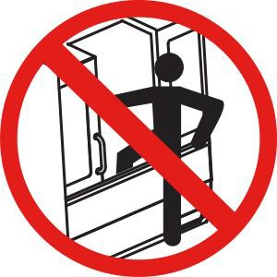 | Do not enter the machine enclosure when the machine is capable of automatic motion.  When you must enter the enclosure to complete tasks, press [EMERGENCYSTOP]orpoweroffthemachine.Putasafetytagonthe control pendant to alert other people that you are inside the machine, and that they must not turn on or operate themachine.
 | Do not machine ceramics.
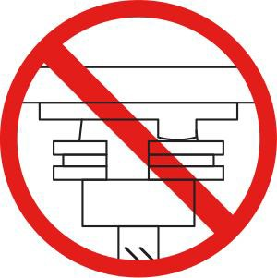 | Do not attempt to load tools with the spindle dogs misaligned with the cutouts in the toolholder V-Flange.
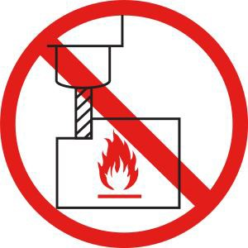 | Do not machine flammable materials. Do not use flammable coolants. Flammable materials in particulate or vapor form can become explosive. Themachineenclosureisnotdesignedtocontainexplosionsorextinguish fire.
 | Do not use pure water as coolant. This will cause machine components to rust. Always use a rust-inhibitive coolant concentrate with water.

7

Recommended Action Symbols – GreenCircles

Symbol | Description
 | Keep the machine doors closed.
 | Always wear safety glasses or goggles when you are near a machine. Airborne debris can cause eye damage.
 | Make sure the spindle dogs are correctly aligned with the cutouts in the toolholder V-flange.
Note the location of the tool release button. Press this button only when you are holding the tool.
Some tools are very heavy. Handle these tools carefully; use both hands and have someone press the tool release button for you.

Informational Symbols – BlackCircles

Symbol | Description
Maintain the recommended coolant concentration.
A “lean” coolant mixture (less concentrated than recommended) may not effectively prevent machine components from rusting.
A “rich” coolant mixture (more concentrated than recommended) wastes coolant concentrate without further benefit over the recommended concentration.

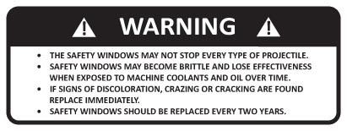

The windows on the machining center are not designed to stop all possible flying material. Improperly clamped work pieces may be thrown through the windows; Serious personal injury may occur. Use care and proper machining techniques during all operations. Replace windows immediately if they are damaged or show signs of wear. Contact the Takam Service Department for Replacement parts.

DECLARATION OF WARNINGS, CAUTIONS, AND NOTES

Throughout this manual, important and critical information is contained in the following:

WARNING!

WARNINGS ARE USED WHEN THERE IS AN EXTREME DANGER TO THE OPERATOR AND/OR TO THE MACHINE. TAKE ALL STEPS NECESSARY TO HEED THE WARNING GIVEN. DO NOT CONTINUE IF YOUCANNOTFOLLOWTHE WARNING INSTRUCTIONS.

CAUTION: Cautions are used when there is the potential for minor personal injury or mechanical damage. Perform the step or procedure following the Caution instructions.

NOTE: Notes are used to give additional information to the operator about a particular step or procedure. This information should be taken into consideration by the operato r as he/sh e performs the step o r procedure to ensure there is no confusion.

  - UnattendedOperation
Fully enclosed Takam CNC machines are designed to operate unattended; however, your machining process may not be safe to operate unmonitored.
As it is the shop owner’s responsibility to set up the machine safely and use best practice machiningtechniques,itisalsotheowner’sresponsibilitytomanagetheprogressofthese methods. You must monitor your machining process to prevent damage, injury, or loss of life if a hazardous condition occurs.
For example, if there is the risk of fire due to the material machined, then you must install anappropriatefiresuppressionsystemtoreducetheriskofharmtopersonnel,equipment, and the building. Contact a specialist to install monitoring tools before machines are allowed to run unattended.
It is especially important to select monitoring equipment that can immediately detect a problem and perform an appropriate action without human intervention.

  - Improper Coolants
Coolant is an important part of many machining operations. When it is correctly used and maintained, coolant can improve part finish, lengthen tool life, and protect machine components from rust and other damage. Improper coolants, however, can cause significant damage to your machine.

Such damage can void your warranty, but it can also introduce hazardous conditions to your shop. For example, coolant leaks through damaged seals could create a slipping hazard.

Improper coolant use includes, but is not limited to, these points:

- Do not use plain water. This causes machine components to rust.
- Do not use flammable coolants.
- Do not use straight or “neat” mineral-oil products. These products cause damage to rubber seals and tubing throughout the machine. If you use a minimum-quantity lubrication system for near-dry machining, use only the recommended oils.

Machine coolant must be water-soluble, synthetic oil-based or synthetic-based coolant or lubricant.

- Specification
  - Vertical Mill Orientation and Operation Position
2.1.1 Vertical Mill Orientation
The following figures how some of the standard and optional features of your Takam Vertical Mill. Note that these figures are representative only; your machine’s appearance may vary depending on the model and installed options.

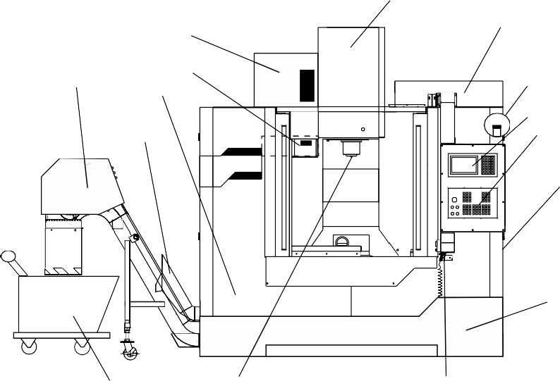
6
5 7
4
1 3 8
9
2 10

11

12

15 14 13
    - Chain Type Chip Conveyor (Optional)
    - Screw Type Chip Conveyor (Optional)
    - Coolant Pumps
    - Umbrella Tool Changer (not shown)
    - Side Mount Tool Changer (Optional)
    - Spindle Assembly
    - Electrical Control Box
    - High Intensity LED Work Light (2x)
    - NC Control Panel
    - Operation Panel
    - Side Window (2x left & right side)
    - Coolant Tank
    - Air Gun
    - Spindle
    - Chip Cart
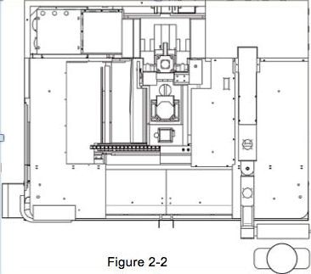
2.1.2 Operating position

The operation position is located in the right rear side of the machine, where the control panel is located. In figure 2-2shows the correct operation position.

  - Outside Dimension

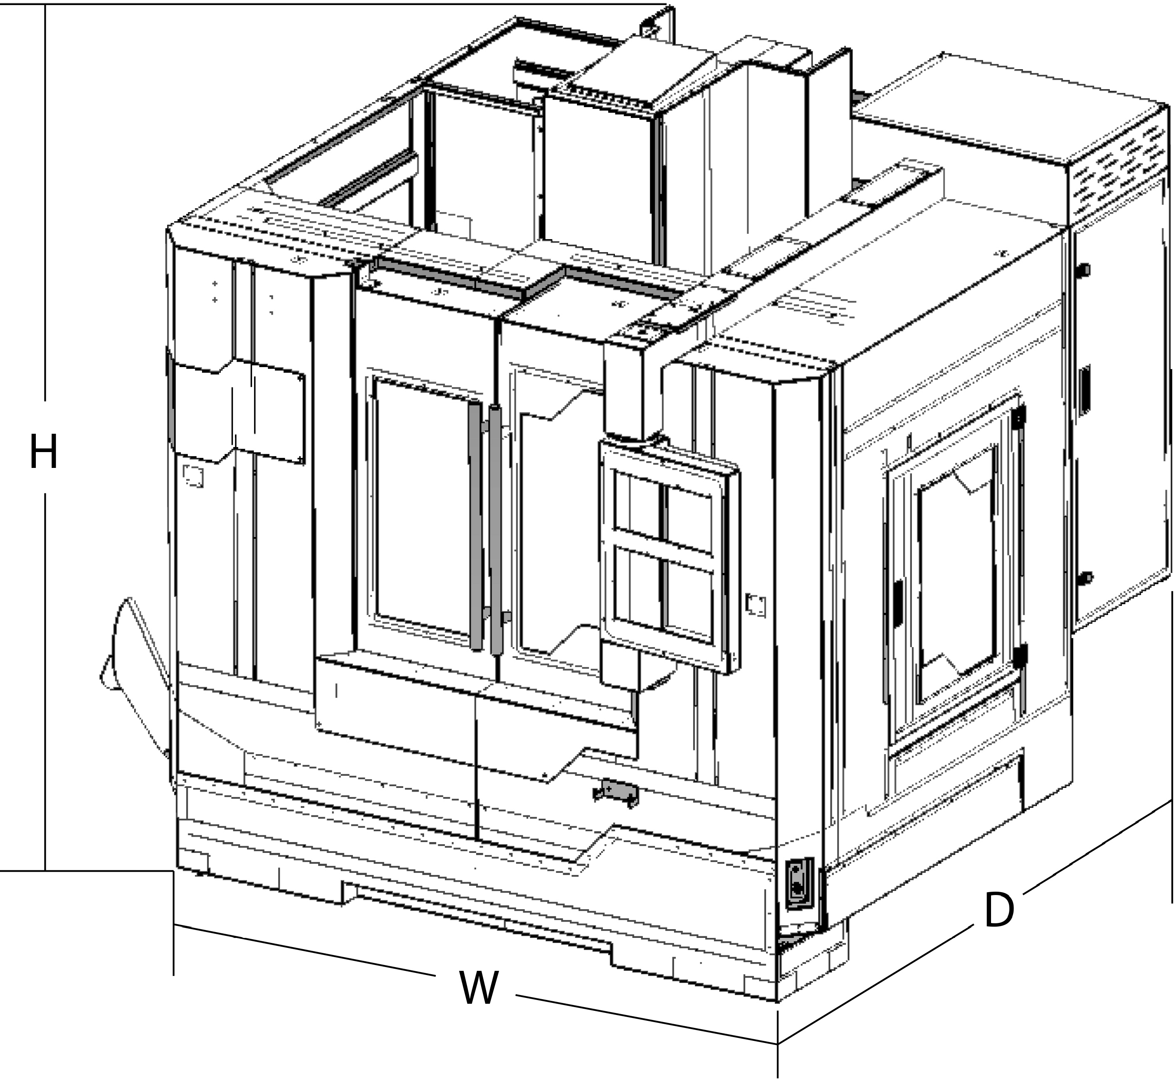

Series | TE-655 | TE-855 | TE-1055 | TE-1060 | TE-1260
DimensionA | 2200mm | 2200mm | 2200mm | 2430mm | 2430mm
DimensionB | 2420mm | 2420mm | 2620mm | 3000mm | 3000mm
DimensionC | 2700mm | 2700mm | 2700mm | 2800mm | 2931mm

  - Machine Specification
Machine specification can be found by visiting our official website: www.takam.com

  - Noise Level

All Takam machines are tested to be under 78 dB. Machines are tested with 8,000 rpm belt type spindle. One meter always from the front door with the door closed.

  - Tools Information

Tool Holders/Pull Studs
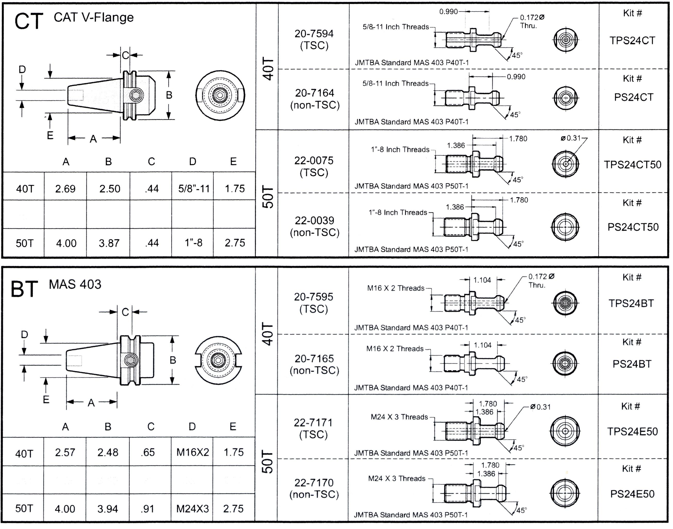

Note: Low air pressure or insufficient volume will reduce the pressure applied to the tool unclamp piston and will slow down tool change time or will not release the tool.

  - Lubrication Usage Types:

OIL USAGE RECOMMENDATION
BRAND ITEM | MOBLE | SHELL | ESSO | CASTROL
LUBRICATOR OF PNEUMATIC | DET  32 | TURBO  T32 | TERESSO 32  NUTO H32 | HYSPIN VG32  PERFECTO T32
GEAR BOX | DET 10 | T10 | H10 | T10
SPINDLE OIL COOLER | DET 32 | TURBO  T32 | TERESSO 32 | HYSPIN VG32 PERFECTO T32

  - Accessories:

Below accessories listed are standard that are included in all machines. Some additional accessories provide might not be listed.
Standard Accessories:

    - Tool box and tools
    - Leveling blocks & bolts
    - Work Lamp
    - Cutting coolant system
    - Auto lube system
    - Full protection guard
    - Guild way cover
    - Warning light
    - Auto power off
    - Hand wheel
    - Air gun
    - Air hose
    - Operation Manual
    - Controller Operation Manual

- Handling and Transportation
  - Important Items before Unpacking
3-1-1. Marks on Machine Packaging:

    - Machines are packaged with export standard package that is required to use its own high ceiling container.

    - Before unloading the machine, marks on the packaging should be looked over for notice and suggestion on loading the machine from the container.

    - Forklift unloading is suggested way of unloading the container. Make sure the forks of the forklift is placed on the correct and supported area on the shipping rack.

3-1-2. Tools for Unpacking:
Below are common tools that are used for unloading the machine:

- Crane of Forklift
- Scissors
- Adjustable Spanner
- Ladder
- Pneumatic Wrench
- Lifting Slings or Chains
- Adjustable Monkey Ranch
- Hammer

  - Transportation before unpacking (crane or forklift is recommend)
    - Before lifting, packaging cover must be opened to be able to reach in to lifting points.

    - The lifting slings of crane should be capable of lifting weight of the machine that it is planning to lift.

    - The lifting slings must be arranged properly according to the center of gravity of machine being lifted.

    - The forklift operator or crane operator should be certified as a qualified & trained person.

    - Machine should be loaded at the center of gravity of truck and avoid inclining to any side.

    - After loading, use slings to fix the machine body on truck and be sure to fasten it firmly before transportation.

    - Make sure packing cover is put back to avoid any dust, water, or other materials that will damage the machine.

  - Transportation after unpacking (Crane or Forklift is recommend)

    - Before lifting packing cover must be opened to be able to reach in to lifting points.

    - The lifting slings of crane should be capable of lifting weight of the machine that it is planning to lift.

    - When moving the machine, keep on the shipping rack that was provided with the machine to stay on the machine for moving.

    - Once location of machine is decided. Ether use crane or forklift to lift the machine off the ground high enough to remove the mounting bolts holding the rack and machine together. Once all bolts are released, put the machine down again and lift the machine ether from the machine with forklift or lifting ring with slings and crane.

    - Once ready to put the machine down again. Put the foot pads under the leveling bolts. This will make the adjustment easier later on for leveling of the machine.

  - Forklift and crane load requirement
Forklift and crane must be able to lift the below machine weight. Using equipment unable to lift the requirement weight may damage the machine and with possibility of causing death.

1. TE-655 4,000 kgs
2. TE-855 4,300 kgs
3. TE-1055 4,600 kgs
4. TE-1060 6,000 kgs
5. TE-1260 6,200 kgs

- Foundation and installation

  - Requirement of environment

While installing machine, try to avoid the following conditions:
- Where the machine is close to heat source.
- Where there is a vibration source in the surroundings, such as press, shearing etc.
- Where the machine tool is close to strong electromagnetic ultrasound or electric welding machine.
- Where it is close to spilling oil, water and chips reach.
- Inclining or bad foundation.
- Where the machine tool is exposed to the direct sunlight.

  - Foundation and requirement

Foundation drawing and requirement are shown below:
- The depth of concrete should be as deep as possible and be sure there is no crank.
- Form cups and humps inside the foundation bolt holes such that
- They may be securely axed to primary concrete.
- Reinforce steel j-hook bars with diameters of 16 x 550 mm will be placed into the foundation for locking down of the machine body.
- The protective earth of electrical system should comply with the local regulations. If there is no relative regulations, please make a grounding terminal with a copper rod (diameter of 15mm, length of more than 2M) embedded in the ground.
- Install machine after 7 or 10 days at least after filling the ground. This will help confirm the concrete is completely dry.
- Install the machine only when concrete it has completely cured. Level the machine temporarily when apply foundation bolt, and leveling blocks, etc. Put the level gauges on the work table to adjust the accuracy of level between 0.02-0.05 mm / 100 mm. Then fill secondary concrete into foundation bolt holes to fasten them.
- Use the concrete that has a non-shrink property to fill the foundation bolt holes.
- Space for installation should be considered not only for machine dimension, but also enough for maintenance and operation.
- Final accuracy adjustment should be readjusted after 7 days of the last dated adjustment.

  - Requirement of Power Source

4-3-1.Main power supply:
Power supply is according to the specification of this machine, transformer and user’s local electric power supply. Please refer to the identification marking located on the back of column, and be sure it is correct before connecting.

4-3-2. Air source limited and requirement: 6 kg/cm2

NOTICE
Non-recommend power source may cause series injury to the operator and damage to the machine.

- Machine Leveling Adjustment

  - Machine leveling adjustment

To reduce vibration and inaccuracy of machine, adjusting level correctly is necessary.

- To adjust level should use two pieces of level gauges that that has a accuracy of 0.02 mm precision per spacing.
- Before adjusting, be sure that leveling gauge is absolutely leveled as follows:
- Put the level at the fixed position on table.
- Record bubble's position after bubble stops moving. And
rotate 180 degrees until bubble stops, it is necessary to compare with 0 degrees get the clearance within 1/3 section position.
- Return X, Y and Z to zero point and move X axis to the middle point of travel.
- Set the level gauge at the middle of table as Figure 5-1.

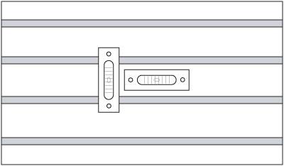

Figure 5-1

- First leveling only use 4 leveling bolts to do the adjustment.
- Adjust the 2 middle bolts closer to the end of the machine and the 2 most from bolts of the machine.
- After the 4 bolts are adjusted move the Y-Axis front to back and see which side the level gauge is moving towards and make adjust according to the movement.
- Once Y-axis leveling is adjusted within 0.04 mm of the gauge. The next 4 bolts can be adjusted.
- Move the work table back to the center of the machine.
- For the last 2 and the 2 middle closer to the front bolts, adjust until it touches the foot pads.
- Slowly tighten the bolts so that it is completely supported.
- Once again move the work table front and back. Check if the leveling is the same.
- If the leveling has moved. Release the bolt of the direction the machine has moved to. This will ether reduce the lift of decrease of the machine.

- Adjust until leveling of the Y-axis movement is within required range.
- Once leveling is complete. Adjust the tightening nut that is attached on the bolt to lock the bolt in position. This will help with keeping the leveling bolts in the correctly adjusted height.
- Check and readjust the machine level every 3-6 months depending the usage condition.

- Maintenance
6.1 General Safety Rules

  - Electrical maintenance should be only done by qualified personnel.

  - To maintain the machine accuracy and longevity. Daily, weekly, monthly, and yearly maintenance and inspections must be done.
  - With the machine turned on, any maintenance operation can be dangerous. The main circuit breaker should be turned off throughout the operation.

  - Do not use compressor air to clean machine or other components.

  - Daily Maintenance

    - Clean chips on the surface of sideway and the guard of each axis.
    - Clean the coolant tank filter system.
    - Check the oil level of slide way and spindle lubrication oil. add oil if necessary.
    - Clean the taper inside spindle.
    - Check the air blows in the spindle head.
    - Check the amount of coolant in coolant tank, and replenish them if necessary.
    - Check the level of cutting fluid. Add it if necessary.
    - Drain the water in the air filter.
    - Clean the environment around machine.
    - Clean the tool, tool shank and tool stud.
    - Check the tool exchanger arm.
    - Check the limit switch, proximity switch and dog.
    - Clean the chips inside the machine work area.

  - Weekly Maintenance
    - Carry out daily maintenance.
    - Clean the air filter in heat exchanger or fan of electrical cabinet.
    - Check if the top of spindle, tool, base and other accessories are damaged. Clean them if necessary.

  - Monthly Maintenance
    - Carry out weekly maintenance.
    - Check if the plug and cables are connected tightly.
    - Clean control panel and heat exchanger filter or AC unit filter.

    - Clean the filter of lubrication unit.
    - Check and clean the pods of the magazine.
    - Check limit travels are all engaged and have not changed.
    - Check working table and the leveling of the base and make sure that the foundation bolt are tighten.
    - Check if the all guide ways are well lubricated.

  - Three month maintenance
    - Carry out monthly maintenance.
    - Clean the oil filter of lubricator pump and tank.
    - Check if the zero point of each axis is stable.

  - Six month maintenance

    - Check if the testing program executes smoothly.
    - Use the program tested to check the action and function of machine.
    - Clean the electric parts in electrical cabinet. Make sure the main power is off before doing so.
    - Check the servo motors of 3-axis, spindle motor, coolant pump, chip extraction conveyor motor and related parts whether they can work normally or creating any noise when they are running. Change the lubrication oil of guide ways, pneumatic system, ATC gear box and spindle oil cooler oil.
    - Re-level the machine.
    - Replace coolant and thoroughly clean the coolant tank.
    - Check all hoses and lubrication lines for cracking.

  - Yearly maintenance

    - Check the joints of lubrication system.
    - Check the support chain of counterweight at the rear of column whether it is broken or damaged. Change it if necessary or if it is still working well, add grease on it (Only for box way machines).
    - Check the precision of machine.

  - Regular maintenance explanation

6-8-1. Maintenance of unclamp system

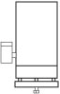
Periodical inspection of oil quantity each 6 months (A dim. = 40-50mm to be standard). It would cause problem in unclamping the tool if the oil is not sufficient. In this case, you could consider to change or contact your agent for repairing.

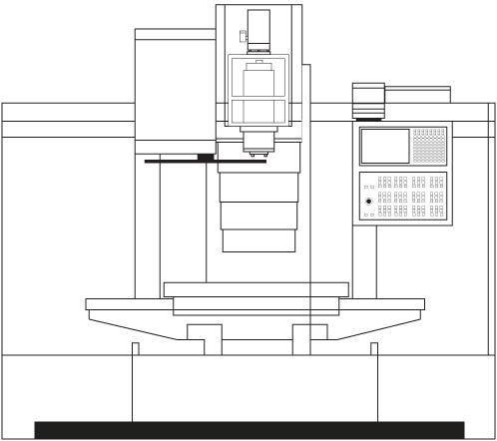
A
Machine Front View

  - Pneumatic circuit unit.
6-9-1. Following Motions are Controlled by Pneumatic System

- Tools unclamp on spindle head.
- Spindle air blow.
- Pot up/down. (arm type)
- Change gear ratio. (gear type)
- Magazine right/left. (armless type)
- Rotary Table 250 mm and smaller.
- Fixtures (optional)

6-9-2. FRL (Filter/Regulator/Lubrication) Unit

- The FRL unit consist of air filter, regulator and lubrication.

  - PRESSURE SWITCH
  - AIR PRESSURE GAUGE
  - WATER COLLECTOR

  - OIL BUCKET
  - DRAIN
  - OIL REGULATOR
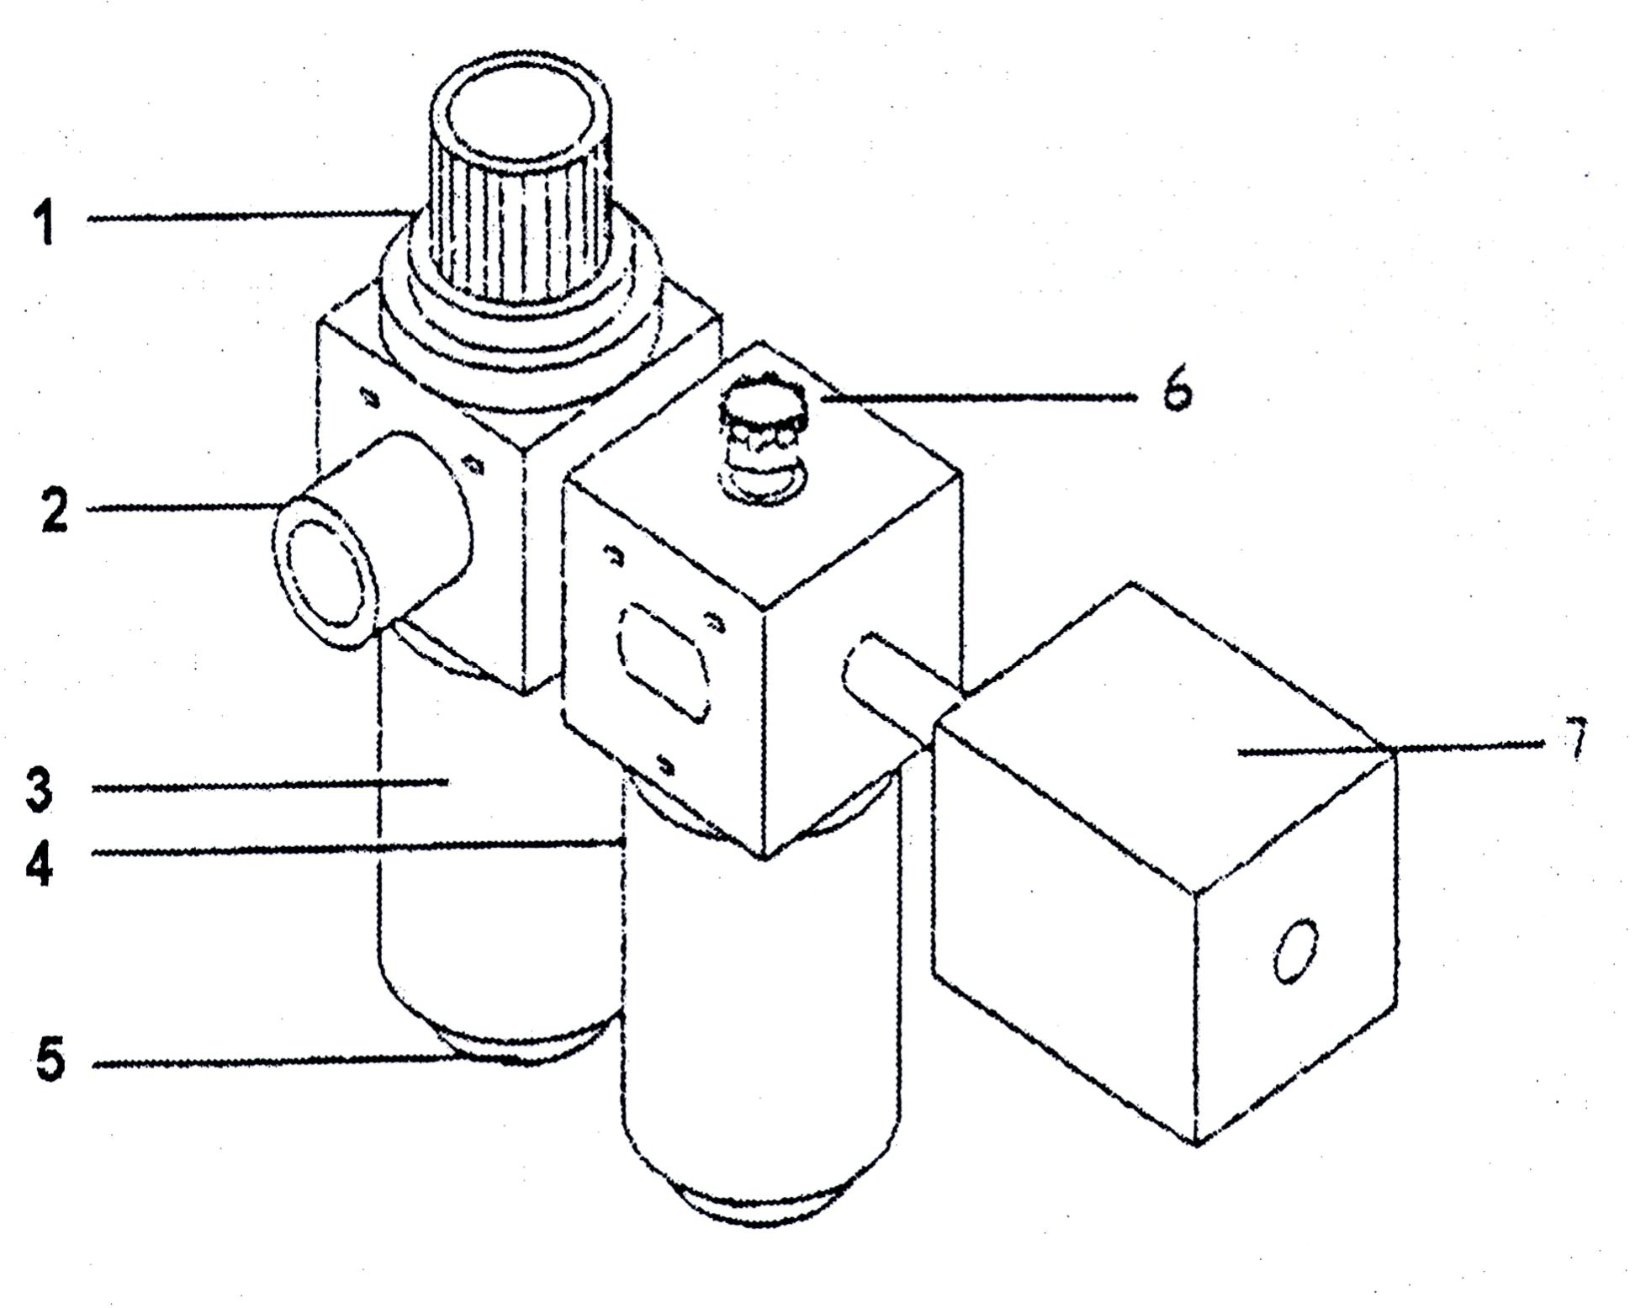
  - AIR PRESSURE DETECTOR
THE PRESSURE SWITCH HAVE MARKED "+" AND "-" DIRECTION: + / INCREASE AIR PRESSURE - / DECREASE AIR PRESSURE

- Set air pressure to 6 kg/cm by adjusting the pressure regulator handle (pull-up the button and twist it in clockwise for increase the pressure and counter-clockwise for decrease).

- Supply lubricating oil to the lubricator before the oil level drops below the lower limits level.

- The lower limits level.

- Lubricating oil: ISO10 or equivalent product.

- When the pressure falls below 4.5 kg/cm the pressure switch is actuated and gives alarm signal on operation panel unit the pressure rise.

- If you want to take off the oil tank to clean or change a new one etc. press the release button and twist the tank in counterclockwise direction.

- Drain water in the air filter daily.

- The compressed air must be supplied by user and it must be clean and dry.

  - Maintenance of lubrication system
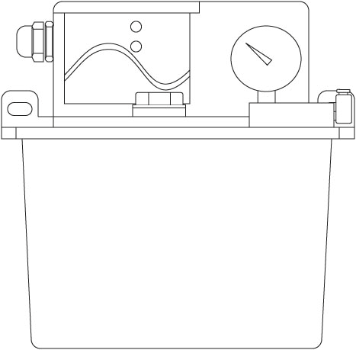
6-10-1. Model: 4 liter lubrication system (PLC Controlled System). Connecting Line Plug Pressure Gauge
Power inlet

Oil outlet

Oil inlet

6-10-2. Operation Manual for Auto Oiler

    - Using Explanation:

      - Input power supply (Please check with specification of motor).

      - In the beginning please add oil to oil tube till lubricant position (i.e. feed oil).
Then link the extreme connector to exhaust air inside the oil tube.

      - Adjust the running time (left button) and intermittent time (right button) for oil amount needed. Then it could run automatically.

      - The alarm would ring when ring when oil amount under the lowest point of oil box. Please replenish clean lubrication oil.

    - Notes:

      - This device is fitted with lubrication oil ISO32 or equivalent product.

      - Add clean lubrication oil only. The used oil is not allowed in order to keep longevity.

      - In order to adjust the amount of time interval the lubrication units distribute the oil can be adjusted inside the controller.

      - Please don't add oil over the red line of oil level in order to avoid the oil diffuse and influence the cleanliness of oiler and work place.

      - Please clean the oil net. interior oil box and output connector every three to six months. For smooth oil-feeding.

      - Add lubrication oil when alarm rings or motor breaks.

6-10-3. Auto lubrication unit trouble shooting

No | Situation | Reason | Method
1. | Get no oil  (motor can’t work) | - Oil passage be blocked by air.  - Pump breakdown.  - Exit be blocked by thing.  - Motor breakdown (burned).  - Electron box breakdown.  - Coupling rubber was swelled (by inferior material).  - The distance of two coupling is too close.  - The line get down from motor  and electron box. | - To release the cup of oil outlet. Lock the cut of oil outlet after all the oil out.  - To change oil pump.  - To clean oil filter, oil tank and exist contractor.  - To change the motor.  - To change the electron box.  - To change coupling rubber.  - To adjust the distance.  - Re-install the electric line.
2. | Motor direction  contrary | Line contact wrongly. | Re-install the line.
3. | Horn ring can’t stop | - Oil tank is out of oil.  - Motor breakdown.  - Slight switch’s direction contrary.  - Slight switch breakdown.  - Red button breakdown. | - Add lubrication oil.  - To change the motor.  - To change the direction of ball switch.  - To change the slight switch.  - To change red button.
4. | Horn can’t ring | - Horn was burned.  - Plastic contract cover pressure or non-contact. | - To change red button.  - Re-install.
5. | No power on electric  box. | IC chip was burned. | To change IC chip.

 | 6. | The cover of electric box broken. | a. The inferior material or delivery | a. To change cover for electric box.
 | 7. | Electric leakage | - the button of wring board copper chip at contacts with oil tank.  - The surface of electric line was broken. | - Get the copper chip out or change wiring board.  - To change the slight switch or add insulated tape.
 | 8. | Oil tank leakage | The screw for oil level was not  locked. | To change the oil tank.

CAUTION

The machine is equipped with auto lubrication system on ball screw and slide ways of Longitudinal and cross travel. It operates automatically when the spindle has been started and lubricates with 3-6cc lubrication oil per shot at the intervals of 30-60 minutes. The insufficient oil lubricant may damage the surface of slide ways. So, do not adjust the timer of auto oil lubricant system by yourself.

  - Cleaning and refilling of cutting fluid tank
Note: Please wear glove and eye protection before cleaning your coolant tank. The used cutting fluid and sediments should be handled according to local environmental protection regulations.

- Steps of cleaning:

  - Make sure all electricity going to the machine is turned off.

  - Prepare a tank for storing used cutting fluid and dismount the pump motor (located on the rear side of the machine).

  - Remove the cover plates on top of the coolant tanks. This will expose a large area of the coolant.

  - Ether a hand pump or an automatic pump to remove the coolant into the used fluid tank.

  - After removing as much coolant as possible. Use a small shovel or tool that can easy help remove the cutting material left in the bottom of the coolant tank.

  - After removing the material on the bottom of the coolant tank. Refill the tank with the correct mixture of the cutting coolant into the coolant tank.

  - Replace all filters, covers, and pump back to the original position. Make sure to tighten all bolts.

- Alarm protocol
  - What to do first

Preface：
This chapter-Alarm Description and Solution-can be applied to all TAKAM machines which are equipped with Mitsubishi controller. We do hone that this explanation of trouble shooting can be helpful for you to repair the mechanical trouble so to make machine resume normal operation.
Caution！
When check or test the electrical circuit under power ON status, it is necessary to be very careful. Implement check and test after the safety appliances have already been set up. Before attempting to do any modification and correction, please make sure that the master power switch has already been switched OFF.
After the master switch is cut off, please be careful that there still has remaining voltage left in the power supply. Please wait at least 3 minutes and then it is able to stat modification and correction operation.
Content of Trouble Shooting
The main purpose of this chapter is to help you to confirm the cause of problem, and teach you how to use the information provided by this manual, so as to assist you to repair the mechanical trouble and make machine restore normal operation condition. There are some useful information you may need to know in foreword. Furthermore, it tells you that when you request TAKAM technical services, what information you should provide to our service department. The correct information can help us to know the machine historical records fast and help us to decide the trouble shooting solution easily and quickly. Moreover, the exact information will be much helpful for our service engineers to find out the solutions earlier.
The operator may refer to the Operation Status Table to understand and notice the operation status. This table contains the discussion on the causes of problems, and the suggestion on the rectification procedures.
The flow chart “Error Judgment / Procedure Confirmation” is the primary guidance for problem solution. Execute test and inspection according to the flow chart. To make sure if the messages which appear during the procedure are the same as the graphic figures on this flow chart is always the best basis for machine repair. Sometimes the problems can be solved in the course of test procedure. Sometimes this flow chart can be helpful to find out some parts need to be replaced. Sometimes you request us for technical supports and the problems can be solved through telephone conversation.
Make sure to record the “Error Message” appears on the screen during operation process. That will be much helpful to sole the problems fast, and on the other hand, it will help you to communicate with our service engineer easily and to solve the problem quickly.
Suggestion
    - Check the information provided by operator, such as the machine motions and the messages displayed on the screen. After executing test and inspection, if these are not the principal factor to cause the problem, it is necessary to research the exact cause again.
    - Usually, you should start trouble shooting by checking and testing operation procedure. Do not request to disassemble machine parts just in the beginning.
    - Deal with the problem one by one. While executing trouble shooting, it is necessary to take cause and result under consideration simultaneously.

Attention
Determine the correct cause while breakdown occurs, otherwise the same error will occur repeatedly. Absolutely, every breakdown has its own cause. Even a small simple part is worn-out, that may cause some other parts broken and lead the system malfunction and stop.
Caution
This machine is the complex combination of computer electronic engineering and mechanical engineering. Please contact with our service department for service, unless you are a well-trained and qualified electronic control engineer.
The operator itself is to collect the truth of problem：
Write down all matters. That can help you to avoid confusing the information collected and help you to make sure their difference as well.
*Be sure that you know what the machine is doing well.
*What message appears on the display？
*Besides present problem, is there any other situation happens？
*Before the breakdown occurs, is there any other strange motion？*What is the motion right before the breakdown happened？
Complete Investigation
Before calling us, you can execute detection and fulfill thorough inspection according to all instruction. That may avoid repeated work and avoid wasting time for telephone communication. For example：Take the error message appears on the screen and user’s explanation under consideration.
That can narrow the detection range and make the problem to be settled easily. Confirm the breakdown situation
      - Record the situation while breakdown occurs：
※ Under which NC operation mode？
※ In the case of AUTO mode：Confirm the program name, program number and program content while the breakdown occurs.
※ In the case of MANUAL mode ：Remember the system is under which manual operation mode and remember the operation procedure.
      - Write down detailed information showed on alarm diagnosis screen.
The procedure to enter into alarm diagnosis screen：
        - Press function selection key “DIAGN”
        - There is a menu selection in the bottom of screen. Press “ALARM” and the alarm screen will show alarm message.
      - Be sure to record alarm signal and content and startup the system again. Please pay attention whether the same breakdown occurs again or not. If yes, please contact with our service department.
Written data
Verify the written data for the machine you operated currently, such as：
※ MODEL No.
※ Serial No.
You can see the above information on name plate or accuracy table.
Execute Inspection
In case you are a well-trained engineer, please remember to take correct safety appliances to protect yourself while you are checking. Please remember not to destroy circuit and electronic parts.
In case you were not well-trained, please call our service department and tell us model number, serial number and the sign of the problem.

Check up the results
Please call our service engineer to discuss what you found out. Our service engineer will check and verify your procedure again. They will carry out a further check and point out some matters which are not evident but you need to know.
We would remind you again that it is necessary to provide detailed information to our service engineer. Besides machine model number and machine serial number, please also prepare electrical manual and parameter table, so our service engineer can provide the most assistance to you in short time.
Be sure that you know the error message. There are over one hundred error messages saved in Mitsubishi controller software. Some messages are quite similar, but possibly refer to different machine parts. In order not to make any mistake, please write down the messages showed in the screen exactly.
To understand the sign of problem. The more you understand machine problems, the quicker to solve the problems. You and our service engineer can find out the better solutions easily.
To understand when did the problems occur? For example：whether this sign refers to a specific block in the program or refers to the specific tools used？ Whether the problem occurred after a
specific operation or occurred in the specific period of a day？ Such information is useful for us to discover why the problem occurred.
Check the LED on circuit board and understand the meaning of LED sing. Some LED on circuit board can provide useful messages for trouble shooting. When the machine is out of order, please pay attention to LED sing in order to shorten the trouble shooting process.

Machine Operation
In the process of trouble shooting, you may probably meet urgent status and you need to execute emergency stop, or maybe you get the machine diagnosis notice that helps operator to solve these matters. However, you may need some more introductions in order to facilitate you to solve the problem with our service engineer.

Emergency Stop
In the case of emergency situation, it is able to press down the EMERGENCY STOP BUTTON (the red mushroom button) to turn off all servo power supply. The screen will show emergency stop message.
The function to release emergency stop：
If the emergency stop button is pressed down, just turn and pull the emergency stop button, the servo power supply will recover automatically and become standby status in order to execute next process.
Machine Diagnosis
There are many error messages refer to machine diagnosis. This part of machine operation system will display the sensed and detected situation, so you can distinguish whether the problem still exist or has situations already been solved.
The position of key components and the RESET button：
You may find out the position of the components, which are involved in the related problems, from the parts list, wiring diagram and manual. That will be helpful to solve problems.
RESET BUTTON can be used to eliminate error and error message quickly. The error message form general operation can be eliminated by RESET button.

  - Malfunction Analysis and Trouble-Shooting (environmental factor)

Status and Message | Cause Analysis | Rectification Procedure
Machine level is variable | The ground bolt is not set properly | Adjust the ground bolt again and fix the nut after the adjustment.
 | Leveling block is more than 2 pieces. | Replace leveling block and do not exceed 2 pieces.
 | The floor ground is not strong enough. | Rebuild ground or execute soil preparation again.
The water cup of F.R.L combination unit drains water frequently. | There is too much steam from the source of compressed air. | - Install a compressed air filter.  - Install a compressed air filter
Air pressure is not enough and that cause machine stops frequently. | Air pressure of compressed air source is lower than 6 kg/cm² | Replace an air compressor with larger capability.
 | Filter unit or dryer is blocked or the  drainage is not well. | - Check up the filter unit.  - Repair or replace the dryer.
 | Air pipe is too long and that causes too much pipe loss. | - Enlarge the diameter of external compressed air pipe or shorten the pipe length.  - Add an air-reserve tank.
The electronic components damaged frequently | There is too much humidity. | Always keep the electrical control box close.
 | There are too much floating dusts particles adhere onto the electronic components and contact  points that cause malfunction. | Always keep the electrical control box close.
 | Main power is not stable and the surge wave is too large. | Install a voltage stabilizer.

The origin point positioning of ARM TYPE tool changer arm is not accurate. | The brake lining of ATC motor is dampened. The coolant splashes up but to be blown down by the fan. That makes the damp to be left on brake lining. | Do not install fan over ATC motor.
Part accuracy is not stable after machining | The temperature difference between storage area and working area is larger. Material expands when heater and contracts when cooled, that cause size variety. | It better to move the maternal to machining area for over 4 hours.

Section 1:Operating Explanation & Function List

Operating Explanation, Function List. And G and M Codes

OPERATING PANEL INSTRUCTION

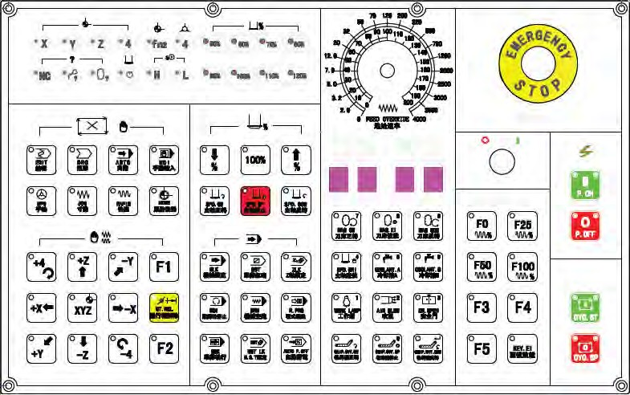
OPERATION PANEL
POWER ON/OFF

POWER ON

- Turn main power switch on which is situated at the rear door of the electric cabinet.
- Press POWER ON button in the operation panel.
- Release EMG STOP switch and machine is started.

POWER OFF

- Confirm all axial moveable parts stop.
- Press EMG STOP button
- Press POWER OFF button in the operation panel.
- Turn main power switch OFF, shutdown is finalizes.

CYCLE START

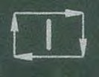

After inputting procedure, swift the mode to memory mode or manual inputting mode, then press start button to carry out procedure. When procedure is carrying, the indicating lamp will light. Start CYCLE START button under the following conditions:

- When procedure is selected and in memory mode, press CTCKE START button to carry out procedure, and the indicator will light till the procedure is over.
Before cycle start, 3 axes should return to ZERO POINT. If not, you should swift the
ZERO POINT requirements OFF in operator function setting screen to start procedure without returning to ZERO POINT.
- In manual document inputting mode, you can input single order, for example, G91 G01 X100. Y100.; then press CYCLE START button to carry out the order. The purpose of this type mode and memory mode are not same and is used in testing some movement, and the indicator will light till the procedure is over.

PROCEDURE PAUSE: FEED HOLD

Press FEED HOLD button can pause cycle and FEED HOLD indicator will light. Auxiliary enginery (M), main enginery (S) and tools enginery (T) will be reserved current state. Press CYCLE START button again, pause is canceled and to carry out the unfinished procedure.

MODE SELECT

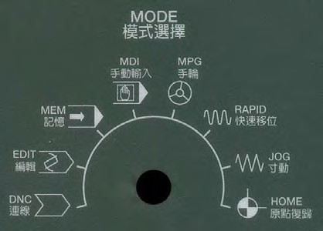

This switch is used to select mode, there are 7 modes for selection: manual document inputting (MDI), memory mode (MEM), DNC mode (EDIT), hand wheel mode (HANDLE), manual continuous feed (JOG), manual rapid continuous feed (RAPID) and zero return mode (HOME). Hand wheel operating mode (OPR) is not available in Mitsubishi controller.

DNC mode (EDIT)
In this mode, operator can use PC computer connected with RS232 controller to carry out DNC work of machining with inputting.

Memory mode (MEM)
Select this mode to carry out automatic operation.

Manual document inputting (MDI)
This mode is mainly used in carrying single order, modifying parameter and setting documents.

Manual input mode (HANDLE)
In this mode, operator controls servo axis feeding by hand wheel. Handle control panel offers speed rate switch with 1, 10 and100 times, minimum unit is 0.001mm or 0.0001mm and axial selection for choosing.

Manual continuous feed rate (JOG)
Operator can choose movement direction to move axis and traverse speed rate controlled by traverse rate in this mode.

Manual rapid traverse (RAPID)
Operator can move axis by axial direction selection in this mode and the speed is controlled by rapid traverse rate button.

Zero point return mode (HOME)
Make every axis return to zero point. Press the direction button of zero point return (same as handle continuous cutting feed button), the axis will move as per the cutting feed rate of the parameters set, when axis touches the stop (DOG), the servo axis will search the position of zero point until it arrives to zero point to stop and the indicator of zero point will light till the axis leave zero point.

Every time you start the machine, firstly you should make every axis return to zero point, and then do other machining work, this can ensure the correctness of every axis coordinate.

SWITCH OF FEED RATE ADJUSTMENT
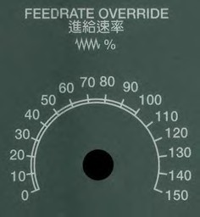
Under automatic or manual mode, make servo axis feed as per G01…F…order, the actual feed rate is toned adjusted by turning the switch from 0% to 150. For example, select F100 means cutting feed rate is 100mm/min, if turn the switch to 50%, actual cutting feed rate is 50mm/min. In most machines, the switch is also effective to servo cutting feed rate under manual continuous cutting feed mode (JOG).
When dry run is effective, this switch can adjust cutting feed rate.

WITCH OF SPINDLE SPEED RATE ADJUSTMENT
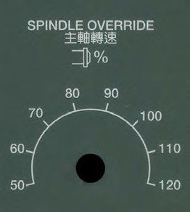
When spindle is in the mode of MEM or MDI, start spindle by instruction (M3 (or M4) Sxx…., this switch can adjust actual spindle speed rate from 50% to 120%. For example, under instruction of M3S1000, lock the switch at 120%, the actual speed rate is 1200rpm.

SPINDLE STOP AND CLOCKWISE/ REVERSE RUNNING
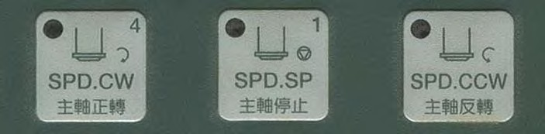
In manual mode (HANDLE, JOG, RAPID), running speed of spindle can be controlled by above three buttons:

STOP: spindle stop running CW: spindle clockwise running CCW: spindle reverse running

In manual mode, no matter spindle clockwise or reverse, speed rate is controlled by stepless type spindle speed adjusting switch from 0 to maximum rated speed. One point need to be noticed` is when switching direction of running, you must press STOP button, or the operation is invalid.

COOLANT and Air SWITCH

There are 2 coolant and 1 air switch.
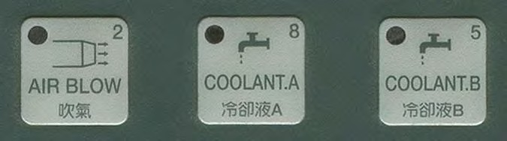

Coolant A & B
The machine is designed with 2 coolant hoses. Both coolant hoses are located next to the spindle. To activate the coolant A or B, push ether bottom showing coolant A or bottom showing coolant B. To deactivate the coolant function from ether A or B, just push the bottom that is already activated and the coolant will stop.

Air Blow
The machine is also equipped with an air blow function. The air hose is located next to the spindle. To air blow function can be activated by pushing the air blow bottom and by pushing the bottom again to deactivate the function.

Emergency stop :EMG-STOP
In conditions of danger or emergency, pressing the button will stop all activities. To cancel the emergency stop mode, turn the switch according to the direction of arrow, and the switch will jump automatic and cancel the stop.
When the button is pressed, system is in the state of unready (state sheet will indicate preparation is unready). Power source of cutting feed driving in electric box will be shut down to get entire safety. Before canceling emergency stop, confirm if the failure has been settled. After canceling emergency stop, carry out zero point returning again to ensure the correction of coordinate.

SWITCH OF RAPID TRAVERSE RATE ADJUSTMENT
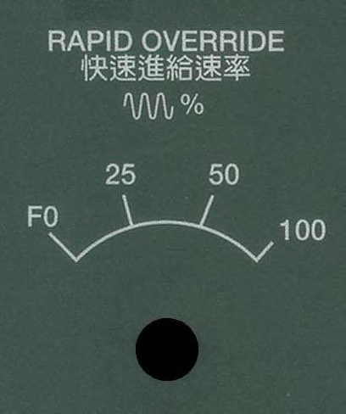

This switch is used to adjust the percent of rapid traverse rate. Rapid traverse rate is in three conditions to carry out procedure G00, manual rapid feed (RAPID) and rapid traverse in front steps of returning to zero point. There totally are four steps: F0, 25%, 50% and 100%. But F0 is controlled by parameter No. 40.

AXIS SELECTION
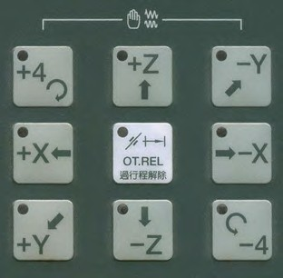
These buttons are used to designate the axis direction in mode JOG and RAPID. For example, press +X button, X axis will move to X axis positive direction. Releasing the button will stop moving.

BDT OPTION BLOCK SKIP
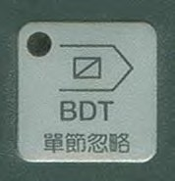
Used in MEM mode to do optional block skip. That’s to say, when pressing the button, single block started with “/” will be omitted to carry out. Contrarily, the function is off; those single blocks will be carried out normally. When the function is applied, indicator will light and press the button again, the function is canceled and indicator off.

SINGLE BLOCK EXECUTING
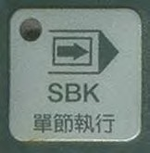
Used in MEM mode to carry out program in only one single block. Press CYCLE START button to start every single block. First press makes function on (indicating light on) and second press cancel the function (indicating light off).

MACHINE LOCK
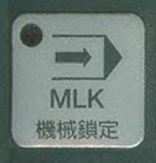
MLK is abbreviation for MCHINE LOCK, when this procedure carrying, controller continues execute procedure but designate of servo axis stop outputting, so servo axis is stopped in fact. In actual operating, procedure will be executed and indicated normally in screen, but the machine coordinate and the machine structure are not moving in fact.

Notice: Every time carrying out this function, zero point return must be done.

DRY RUNNING
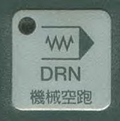
Dry run function is only available in MEM mode. Press this button (indicator light on), servo feed rate is as per dry run parameter (No. 1050) but not speed rate in procedure designated. Generally speaking, speed of dry run is fast because it doesn’t carry out cutting work but to confirm the cutting path and cycle. In general cutting work, the function should be canceled; otherwise there will be danger. The function is invalid to screw cutting designate.

OPTIONAL STOP
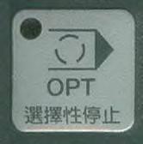
Press this button (indicator light on), every time the cycle is to M01, the function is same to M00, and the carrying block will pause. If want to continue the block, press CYCLE START button (indicator light on). If don’t select the function (indicator light off), controller will omit M01 and carry out next single block directly.

OVER TRAVEL RELEASE

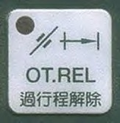

OT REL is abbreviation for Over Travel Release. There are two limit switches in both side of servo axis travel used to prevent servo structure from crashing and damage. Every time the servo structure touches the limit of travel, over travel happens. This condition is same as emergency stop and “EMERGENCY STOP OR OVER TRAVEL” will appear in screen. You must check if servo structure is over travel. If over travel appears, swift mode to HANDLE or JOG, then press the button (indicator light on), controller will omit emergency state of over travel and can permit operator move the servo axis back in the travel scope by hand wheel or axis direction button, then release the button and recover travel test. If all are in normal, “READY” will take place “UNREADY” means the machine recovers in order and can continue working. If there alarm information appears, before recovering in normal, you should use “RESET” button again. When moving back to travel scope, pay attention to the movement direction and speed rate to avoid crashing happen.

Notice: When preparation is unready, it maybe means over travel appearing, when checking the reason, list over travel in checking items.

TOOL MAGAZINE ROTARY (CW)

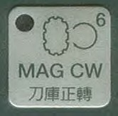

Tool magazine rotate CW by manual. In MDI mode, press the button (indicator light on), tool magazine will turn clockwise till release the button, and the magazine will stop at next position. The state of button can’t self-hold, in another word, when you release the button, the function will be canceled (indicator light off).

INDICATING LIGHT OF ZERO POINT RETURN
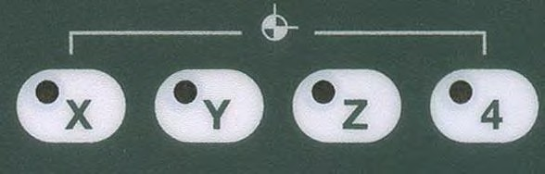
There totally are 4 zero point state lights in control panel used to indicate if the servo axis is stopped at designated the first home point and the second zero point.

AUXILIARY ENGINERY

The function is used to control enginery ON and OFF. Format of the order is M followed with one or two digit numbers. M code is auxiliary code with fixed functions lies inside of controller. It is not decided by manufacturer’s design and this kind of codes are M00, M01, M02, M30, M98, and M99. In another word, these functions have no relation to LADDER CYCLE.
M00: Programmable stop
When CNC carry out instruction to M00, the procedure will pause to let operator check dimension or modify error. If want execute procedure again, press CYCLE START button.

M01: Optional stop
This function is similar with M00, but Optional stop button on panel controls M01. When indicating light on, procedure will pause when procedure is executed to M01. When indicating light off, M01 is invalid.

M02; Gram end
There is M02 in the end of main program. When CNC carries to this instruction, machine will stop all movements. If want to execute procedure again, valid way is to firstly press “RESET” button, then press CYCLE START

M30: Program end and rewind
Procedure end, the function is same to M02, the difference is vernier will return to origin.

M98: Call subprogram
The format of call subprogram is as followed: M98P L ;
P _: name of ancillary cycle L :times of executed
The following is M code list. M00, M01, M02, M30, M98, M99 are fixed function designed by LADDER CYCLE , other M codes in the list, the functions are not designated by system and will be different for the table variability. Operator must confirm the table specification. (The functions in the list are standard LADDER).

Section 2: Machine Foundation Drawing

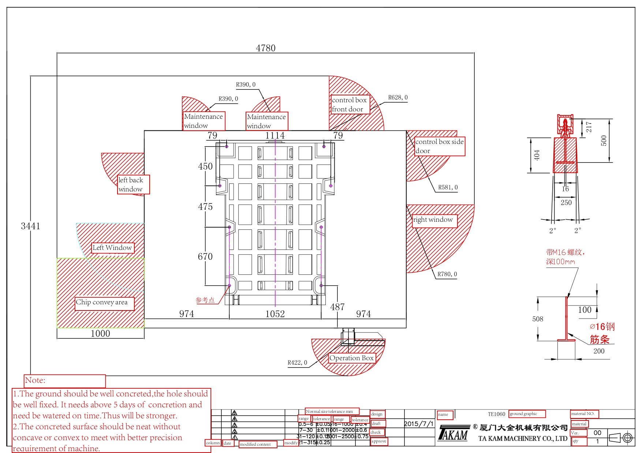

Section 3: Laser & Accuracy report

